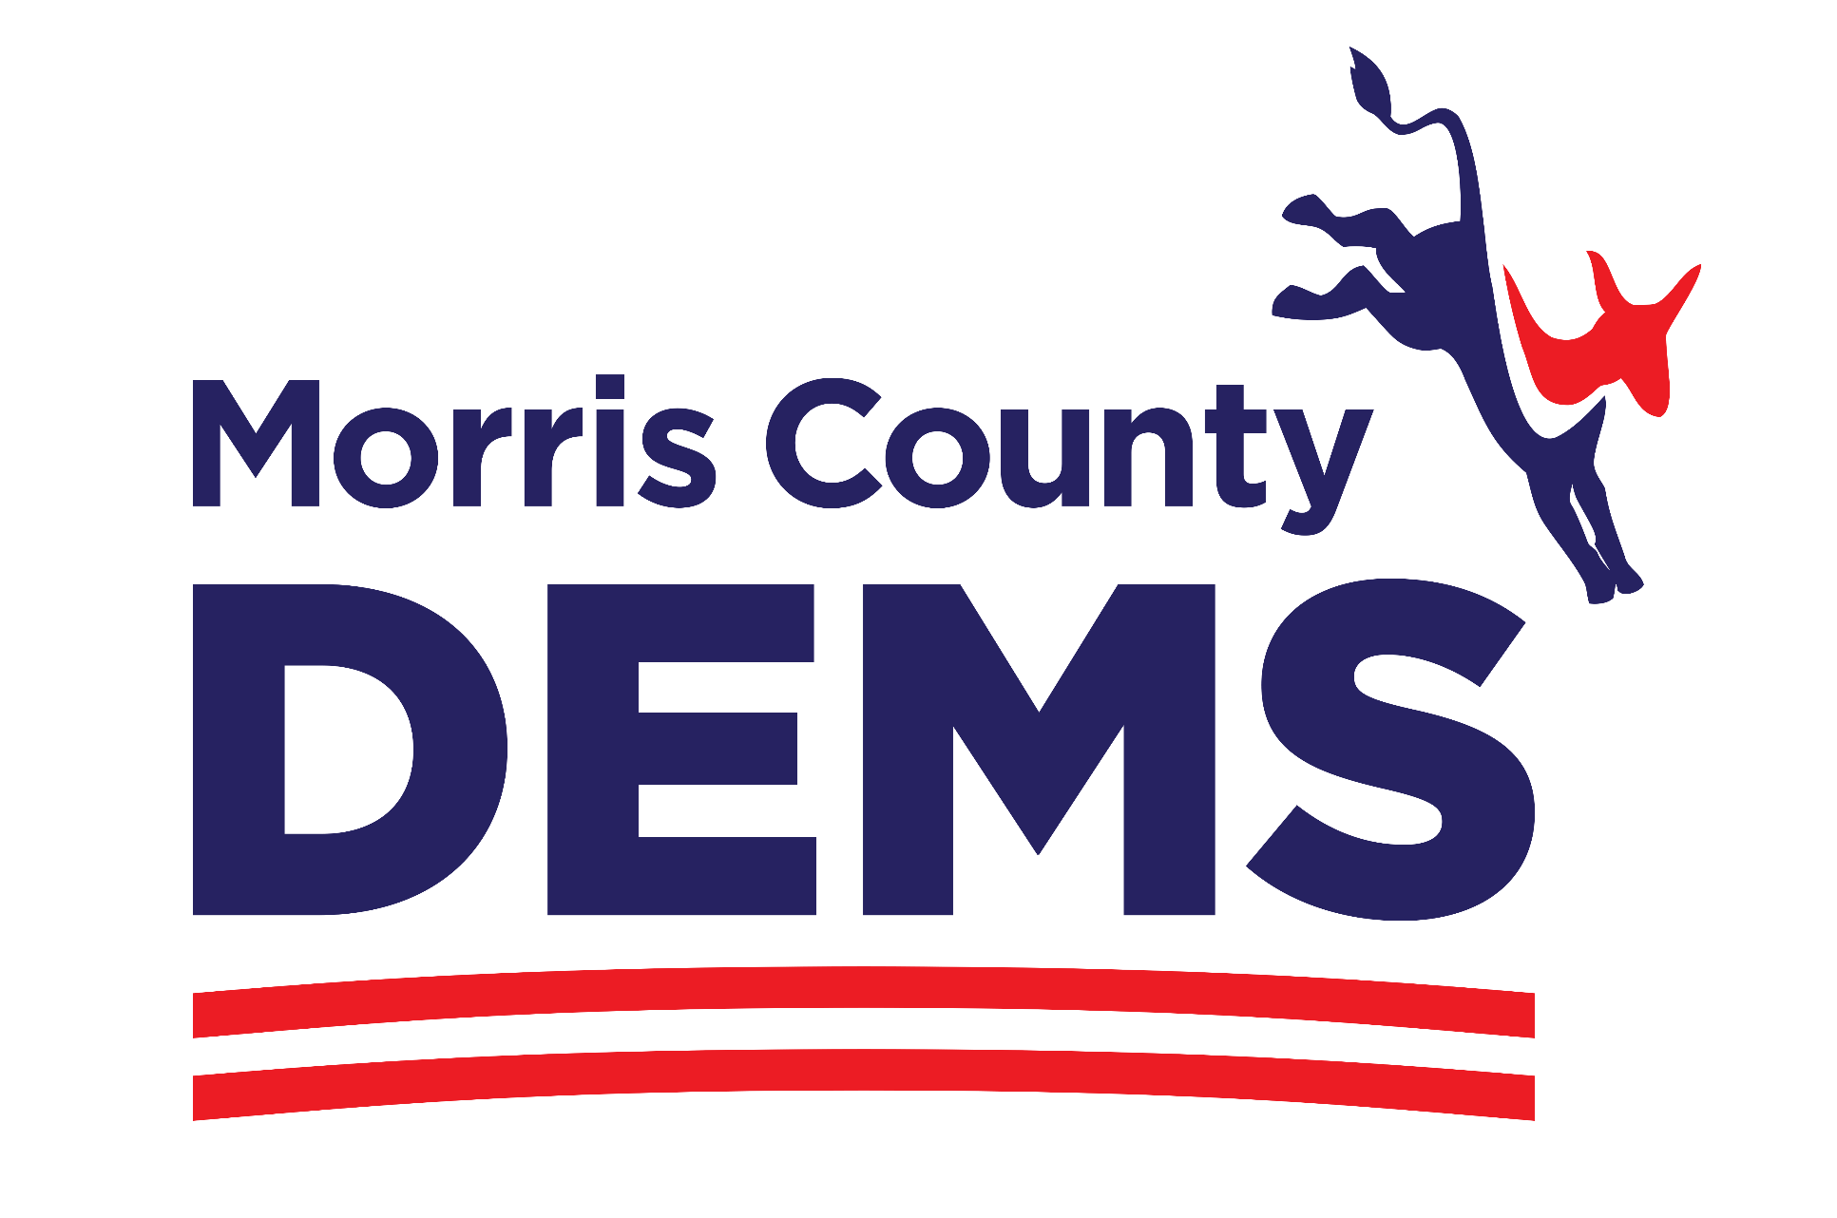
IMMEDIATE RELEASE
March 18, 2024
Contact:
Amalia Duarte
chair@morrisdems.org
(973-902-8390)

Morris County Democratic Committee Overwhelmingly Endorses
Congressman Andy Kim for U.S. Senate!

MORRISTOWN - The Morris County Democratic Committee is excited to announce that its members have overwhelmingly voted to endorse and award the organizational ballot line to Congressman Andy Kim (D-3) for U.S. Senate.

Following the county convention on Saturday, 540 eligible delegates voted using an online, secret ballot, representing a 90% turnout.

Congressman Andy Kim received 457 votes, 85% of the total. First Lady Tammy Murphy received 57 votes, 10%, and Dr. Patricia Campos-Medina received 26 votes, 5%.

“We’re fighting to protect our democracy against extremists, and Congressman Andy Kim is the right candidate for this moment,” said Morris County Chairwoman Amalia Duarte. “Congressman Kim embodies the true spirit of public service and integrity that is so desperately needed at this time of distrust in our public officials and institutions. He has stood up for democracy, from stepping up to run for a Republican-held seat in 2017 to picking up the pieces in the U.S. Capitol after the Jan. 6th insurrection. Congressman Kim will fight for our precious democratic values as our state’s next U.S. Senator.”

At Saturday’s convention held at the County College of Morris, the Morris County Democratic Committee proudly endorsed by acclaim: Joseph R. Biden for President; Mikie Sherrill for U.S. House of Representatives, Congressional District 11; and Sue Altman for U.S. House of Representatives, Congressional District 7.

The endorsement of Congressman Kim culminates an open and transparent process that started in January. The Morris County Committee hosted public Town Hall forums for each candidate at the County College of Morris and asked questions submitted by members. The events were videotaped for distribution to those who could not attend, so everyone had an opportunity to hear from the candidates.

Chairwoman Duarte and the Municipal Committee Chairs all refrained from endorsing candidates in advance of the county convention. All senate candidates were given a final opportunity to make their case for support at Saturday’s convention.

Online voting started after the convention via a secret and secure ballot and ended at midnight on Sunday. Nearly 600 Morris County Democrats were eligible to vote: county committee members, elected officials, municipal chairs, caucus leaders, state committee members and the executive board. [NOTE: If an individual holds more than one position (ex: elected official and municipal chair), they are only eligible for one vote.]

“This is an endorsement model other counties should follow to allow the broadest possible participation and give Party members a voice in the process,” said Chairwoman Duarte. “Like many Morris County Democrats, I got involved in 2017 to be part of a larger movement and to make a difference. That’s why this small ‘d’ democratic process is so important to me. A secret ballot is sacred and an integral part of the democratic process.”

The Morris County Democratic Committee is also thrilled to endorse three local elected officials to run for the office of Morris County Commissioner.

- Bud Ravitz, a two-term Morris Township Committeeman and former Deputy Mayor
- Jonathan Sackett, a two-term Rockaway Township Councilman, and former Council President and Vice President
- Justin Strickland, a newly elected Chatham Borough Councilman

“This is an incredibly strong slate of candidates who will bring their practical, boots-on-the-ground experience to the county level,” said Chairwoman Duarte. “We need to break up the long held one Party monopoly of our county government and bring diverse, fresh, new ideas to the table.

######

